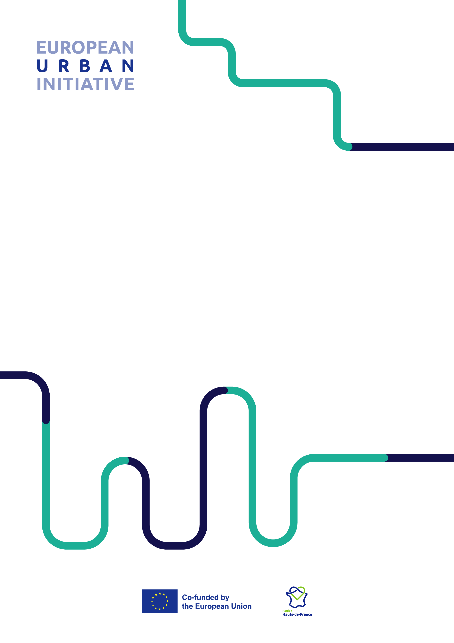

Application Form Courtesy Document – Cities under review
CAPACITY BUILDING

04 April 2023

Please note that this document is a working document whose purpose is solely to help European Urban Initiative applicants to be Cities under review in developing their Application Forms.

This document will not be considered as a formal Application Form.

Only Application Forms submitted through the online EU Survey Platform will be considered by the European Urban Initiative Permanent Secretariat (Permanent Secretariat).

Please note that the working version below represents a simplified version of the full Application Form template available in EU Survey. Furthermore, there is no guarantee that this version corresponds 100% to the latest official version included in EU Survey. You are strongly encouraged to login into EU Survey as early as possible. Do not wait until the last days of the Call for Applications.

Please read the Applicant Guidance (here) before starting to complete the Application Form.

Character limits are to be considered including spaces. It may help applicants to fill in the working document to have the complete overview of the application.

As a final reminder to all applicants, please bear in mind that applications are evaluated by evaluators that may not be familiar with the specific context and challenges of your urban areas, therefore information provided in the Application Form should be clear, sufficiently detailed, and easy to grasp.

TABLE OF CONTENTS

PART A – Applicant information 4
PART B – Challenge and motivation 7
B.1 Challenge and motivation 7
B.2 – Logistics for the peer review 9
PART C – Endorsement from the Urban Authority 10
C.1 Confirmation of endorsement 10
C.2 Contact details of the authorised signatory 11

PART A – Applicant information

A.1. Name of applying urban authority (English)
Please state the name of the applying urban authority

A.2. NUTS 3 code
Please provide the NUTS3 code of the urban authority.
NUTS3 codes are available on the EUI website, in this table.

A.3. Total number of inhabitants
Data to be taken from this table.
Please indicate the total number of inhabitants in the applying urban authority.
[300 characters maximum]
(OPTIONAL) Please provide any other additional statistics from other sources if needed (e.g., national statistics).

A.4. Legal status
Please select the legal status of the applicant.
[Select from list]
- A Local Administrative Unit defined according to the degree of urbanisation as city, town or suburb
- An association or grouping of urban authorities with legal status of organised agglomeration composed by Local Administrative Units
The applicant may refer to the section on Eligible authorities for further details in the Guidance for cities under review.

A.5. EU Member State
Please indicate the EU Member State the urban authority is from.

A.6. Level regional development
Data to be taken from annexes of Commission Implementing Decision (EU) 2021/1130 of 5 July 2021 (available here).
The urban authority is located within a:
[Select from list]
- Less developed region
- Transition region
- More developed region

A.7. Involvement in article 11 of the current ERDF Regulation (2021-2027)
Is the urban authority an “article 11 city”?
[Select from list]
- Yes
- No
- I don’t know
"Article 11 cities" are those selected within each EU Member State to contribute to the selection of operations based on Sustainable Urban Development strategies in line with Article 11 of Regulation (EU) 2021/1058 of the European Parliament and of the Council of 24 June 2021 on the European Regional Development Fund and on the Cohesion Fund.

A.8. Involvement in article 7 of the past ERDF Regulation (2014-2020)
Was the urban authority an “article 7 city”?
- Yes
- No
- I don’t know
"Article 7 cities" were those selected within each EU Member State to contribute to the selection of operations based on Sustainable Urban Development strategies in line with Article 7 of Regulation (EU) No 1301/2013 of the European Parliament and of the Council of 17 December 2013 on the European Regional Development Fund and on specific provisions concerning the Investment for growth and jobs goal and repealing Regulation (EC) No 1080/2006.

A.9. Involvement in EU cooperation related to Sustainable Urban Development.
Please indicate if the urban authority is involved in any of the below.
[Select from list]
- URBACT
- Urban Innovative Actions / European Urban Initiative – Innovative Actions
- Urban Agenda for the EU
- Council of European Municipalities and Regions
- Other(s)
This field is for information only and will not have any impact on the selection process.
[1000 characters maximum]
If so, please name the relevant project / network / partnership(s) and clarify how this exchange will build on this involvement.

A.10. Involvement in the Urban Development Network
Did you benefit from a peer review organised by the Urban Development Network in the 2014-2020 period?
[Select from list]
- Yes
- No

A.11. Contact details from the urban authority
Please indicate the following information for the two contact persons | Main contact person | Second contact person
Full name
Position
E-mail address
Telephone number (with country code)

A.12. Address of the urban authority
Please state the address of the urban authority, including street name, town and post code.
Street and number
Postcode
City
Region
Country

PART B – Challenge and motivation

B.1 Challenge and motivation
B.1.1. Name of Sustainable Urban Development strategy
[500 Characters]
Please provide the name of your Sustainable Urban Development strategy in English and original language.

B.1.2. Status and timeline
[600 Characters maximum]
Please provide information on the status and timeline for the strategy's design phase.

B.1.3. Results from the Self-Assessment Tool for SUD strategies (SAT4SUD)
Please upload the SAT4SUD analysis, including the map and the detailed statements.
The Self-Assessment Tool for Sustainable Urban Development strategies is available here.

B.1.4. Guiding questions
[2500 Characters maximum]
Please indicate three challenges related to the design and implementation of your SUD strategy that you wish to tackle in the peer review.
Please clarify which of the six building blocks of the Handbook for Sustainable Urban Development strategies your challenges refer to.
Challenges should build on your SAT4SUD analysis and the six building blocks of the Handbook for Sustainable Urban Development. Please clarify which of the six building blocks your challenges refer to.
The three challenges should be built on the results of your SAT4SUD analysis and should be related to one of the six building blocks of the Handbook for Sustainable Urban Development strategies:
- Strategic dimension
- Territorial focus
- Governance
- Cross-sectoral integration
- Funding and finance
- Monitoring

B.1.5. Motivation for applying
[1500 Characters maximum]
Please clarify what the applicant expects to gain from this peer review and their motivation for applying.

B.1.6. Participant(s) from the city under review
Please indicate which person(s) will participate in the peer review and what contribution they are expected to make.
Note: Cities under review may bring up to four participants (including at least one staff member from the urban authority that is in charge of the design or implementation of the SUD strategy).
 | Type of institution | Full name | Position | Role in designing and/or implementing the SUD strategy and expected contribution to the peer review
1 | Person from the urban authority in charge of designing / implementing the SUD strategy | Please provide the full name of the person. | Please provide the position of the person. | [1000 Characters maximum]  Please provide the personal involvement and role in the design / implementation of the SUD strategy or integrated, participatory, place-based strategies.
2 | Please select if participant is from:  [Select from list]  - The urban authority  - A stakeholder | Please provide the full name of the person. | Please provide the position of the person. | [1000 Characters maximum]  Please provide the personal involvement and role in the design / implementation of the SUD strategy or integrated, participatory, place-based strategies.
3 | Please select if participant is from:  [Select from list]  - The urban authority  - A stakeholder | Please provide the full name of the person. | Please provide the position of the person. | [1000 Characters maximum]  Please provide the personal involvement and role in the design / implementation of the SUD strategy or integrated, participatory, place-based strategies.
4 | Please select if participant is from:  [Select from list]  - The urban authority  - A stakeholder | Please provide the full name of the person. | Please provide the position of the person. | [1000 Characters maximum]  Please provide the personal involvement and role in the design / implementation of the SUD strategy or integrated, participatory, place-based strategies.

B.1.7. (OPTIONAL) Suggestions for peer(s)
[1000 Characters maximum]
Please indicate if you have any suggestions for the type of peer(s) you would like to be reviewed by. You may indicate up to four types of peers.
Type of peers may include preferences in the context (geographical, institutional, socio-economic), or specific thematic expertise of the peer. The name of a person / institution / city / region / country may be indicated in this field.
Note: A request for specific types of peers cannot be guaranteed. This information is used to facilitate the selection of peers that will review SUD strategy.

B.2 – Logistics for the peer review
B.2.1 Host city
Are you willing to act as a host city for a peer review event, supporting EUI with the organisation (e.g., suggesting possible venues and local service providers, itinerary for study visit, contribution to plenary agenda with city representatives, etc.)?
[Select from list]
- Yes, I’m interested.
- No, I’m not interested.
EUI cannot guarantee you will be selected as a host city.
Are you willing to be a city under review even if not selected to host the peer review event?
[Select from list]
- Yes
- No

B.3.2 Preferred dates
Please rank your preferred dates for the peer review.
[Use drag & drop or the up/down buttons to change the order on EU survey]
( ) Late October.
( ) Early November.
( ) Late November.
( ) Early December.
Preferred dates at the moment of the application are indicative and will be confirmed at a later stage.

PART C – Endorsement from the Urban Authority

C.1 Confirmation of endorsement
This application is made on behalf of the urban authority you are representing. Only applications that have received endorsement from an authorised signatory with delegation and power to engage the legal person of the urban authority are deemed eligible. In case of any doubt, EUI PS may contact the authorised signatory listed in the question C.2 of the Application Form.
By endorsing this Application Form, the applying Urban Authority hereby confirms that:
- The information provided in the Application Form is accurate and true to the best knowledge of the urban authority.
- The urban authority listed in the Application Form:
  - is committed to participate in the action and more specifically is committed to produce a background paper, participate in a preparatory webinar, participate in the peer review event, draft a follow-up report and participate as a peer in later peer reviews.
  - has stable and sufficient resources to carry out the activity.
  - Understands the expectations in terms of communication, capitalisation and to act an ambassador for EUI peer reviews.
- The urban authority commits to comply with the eligibility criteria and all other conditions set out in the Call for application conditions for the entire duration of the activity.
- The urban authority will act according to the provisions of the relevant national and EU legislation and policies as well as the specific provisions of the European Urban Initiative.
- The urban authority is NOT subject to an administrative sanction (i.e. exclusion or financial penalty decision).
- The urban authority (or persons with unlimited liability for debts) is NOT in one of the following exclusion situations:
  - bankrupt, being wound up, having the affairs administered by the courts, entered into an arrangement with creditors, suspended business activities or subject to any other similar proceedings or procedures.
  - in breach of social security or tax obligations.
- The urban authority (or persons having powers of representation, decision-making or control, beneficial owners or persons who are essential for the award/implementation of the action) is NOT in one of the following exclusion situations:
  - guilty of grave professional misconduct.
  - committed fraud, corruption, links to a criminal organisation, money laundering, terrorism-related crimes (including terrorism financing), child labour or human trafficking.
  - shown significant deficiencies in complying with main obligations under an EU procurement contract, grant agreement, prize, expert contract, or similar.
  - guilty of irregularities within the meaning of Article 1(2) of Regulation No 2988/95,
  - created under a different jurisdiction with the intent to circumvent fiscal, social or other legal obligations in the country of origin (including creation of another entity with this purpose).
- The urban authority is NOT subject to a conflict of interest in connection with this grant and will notify — without delay — any situation which could give rise to a conflict of interests.
- The urban authority neither in whole nor in part have or will receive any other complementary EU funding on the tasks carried out within the activity during the whole duration of the activity.
- General information about this project can be used by the European Urban Initiative to liaise with national and regional authorities in charge of implementation of operational programmes funded by the European Structural and Investment Funds.

If the application is selected, EUI PS commits to:
      - Provide technical guidance to the city under review, including two experts in the peer review methodology allocated to the city under review.
      - Provide up to four peers with relevant experience and experience on the three challenges to be addressed during the peer review.
      - Provide logistic and organisation support, with the organisation of all steps of the peer review process.
      - Provide financial support with the reimbursement of travel and per diem (including subsistence and accommodation) if the city under review is not hosting the event and providing all conditions described in the Guidance for Applicants for Cities under Review are met.
Please confirm that your institution endorses this application for a Peer Review, understands the conditions stated above, and will support its implementation if this application is approved.
[Please tick the box if the authorised signatory endorses the application]
Please note that the endorsement of your institution is an eligibility criterion for your application to be selected.
- Yes, I confirm my institution endorses the application, will support its implementation, and that the endorsement comes from an authorised signatory.

C.2 Contact details of the authorised signatory
Please provide the name / position / email address / telephone number of the institutional representative with delegation and power to engage the legal person of the urban authority and authorising the application.

Authorised signatory
Full name
Position
E-mail address
Telephone number (with country code)

See Article 136 EU Financial Regulation.
See Articles 136 and 141 EU Financial Regulation.
See Articles 136 and 141 EU Financial Regulation.
Professional misconduct includes: violation of ethical standards of the profession, wrongful conduct with impact on professional credibility, false declarations/misrepresentation of information, participation in a cartel or other agreement distorting competition, violation of IPR, attempting to influence decision-making processes or obtain confidential information from public authorities to gain an advantage.

